- Create one VPC,with 1 one public subnet and 1 private subnet
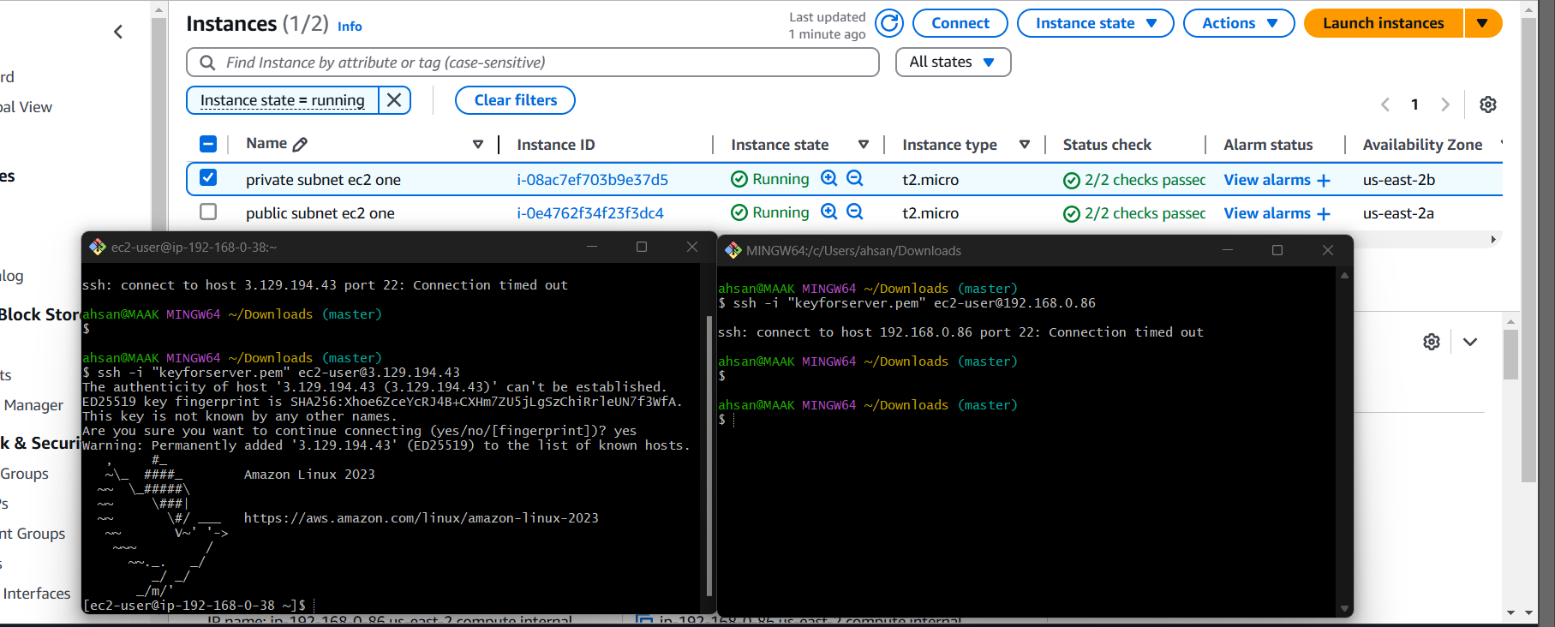
- Enable VPC peering for cross region.

